# CAR PARKING SYSTEM

**Introduction:**

The Car Parking System is designed to automate the process of managing parking spaces. The Arduino-based system incorporates IR sensors to detect vehicle presence at entrance and exit points. A servo motor controls the gate barrier, allowing or denying access based on available parking slots. The 20x4 LCD Display provides real-time information about available slots and entrance/exit statuses.

**Key Components:**

**Arduino Uno:** Central control unit for system operations.

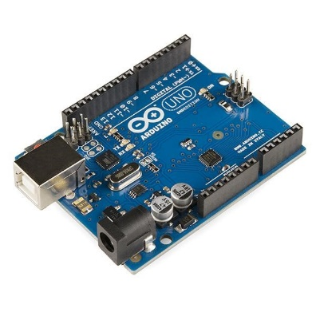

**20x4 LCD Display:** Presents parking slot availability and system messages.

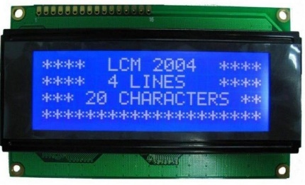

**IR Sensors:** Detects vehicle presence at entrance and exit points.

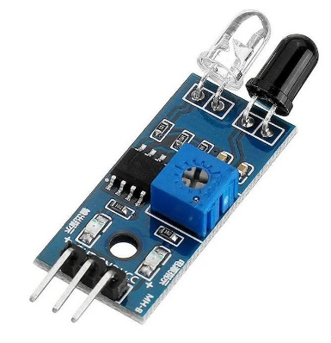

**MG995 Servo Motor**: Controls the gate barrier to allow or deny access.

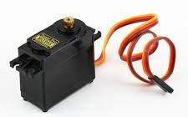

**System Functionality:**

**Entrance Monitoring:** IR sensors detect incoming vehicles. If space is available, the gate barrier opens, and the vehicle is allowed to enter. Otherwise, entry is denied.

**Exit Monitoring:** IR sensors detect exiting vehicles. The gate barrier opens, allowing vehicles to exit while updating the available parking slots.

**LCD Display:** Provides real-time updates on total slots, available spaces, and status of individual parking slots.

**Conclusion:**

Car Parking System successfully demonstrates an automated solution for managing parking spaces using Arduino Uno, IR Sensors, Servo Motor, and an LCD Display. The system efficiently controls vehicle entry and exit, effectively managing available parking slots and providing users with real-time parking status updates.

**Key Features:**

Automated parking slot management.

Real-time display of available parking spaces.

Efficient gate control using IR sensors and a servo motor.

**Circuit diagram:**

